
Tertiary Infotech Academy Pte Ltd
UEN: 201200696W
LEARNER GUIDE
For
Designing and Implementing Microsoft DevOps Solutions (AZ-400)
TGS Ref No: TGS-2024042605
Conducted by
Tertiary Infotech Academy Pte Ltd
UEN: 201200696W
Version 1

Document Version Control Record
Version Number | Effective Date of Release | Summary of Included Changes | Author
1 | 8 July 2026 | First AZ-400 courseware build aligned to all 8 hands-on labs. | Tertiary Infotech Academy Pte Ltd

Course Information
Course Title | Designing and Implementing Microsoft DevOps Solutions (AZ-400)
TGS Ref No. | TGS-2024042605
Duration | 2 days / 16 training hours
Delivery Mode | Instructor-led classroom training with hands-on Azure DevOps labs
Lab Source | courseware/labs-source, copied from the referenced GitHub labs repository
Learner Guide Markdown Mirror | LG-Designing and Implementing Microsoft DevOps Solutions (AZ-400).md

Course Overview
This guide supports learners through the complete AZ-400 lab sequence. Each lab section mirrors the source lab with objectives, detailed steps, validation checks, review questions and evidence expectations.

DevOps Delivery Flow
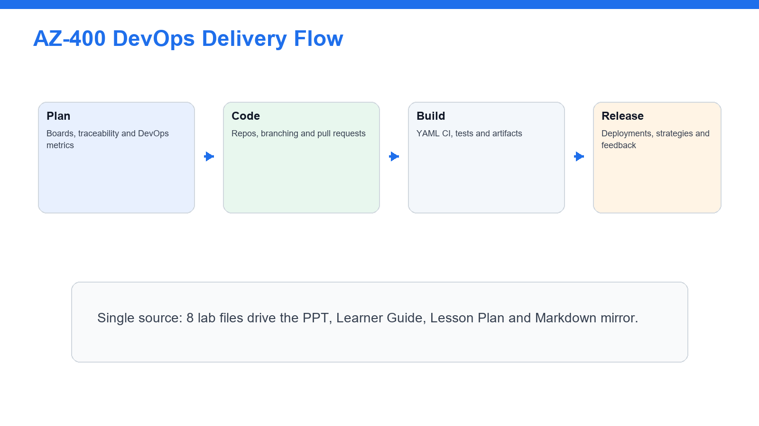
The lab sequence follows a complete plan-code-build-release-observe-improve workflow.

Secure DevOps Governance Loop
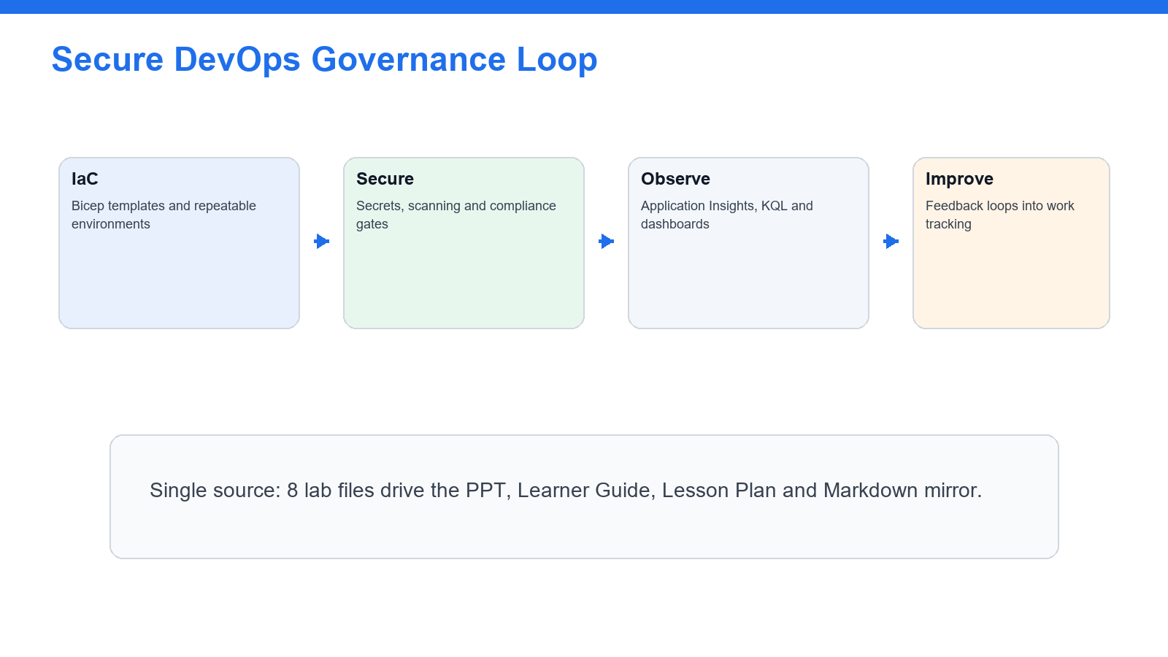
Security, compliance, monitoring and feedback are woven through the later labs.

Lab-to-Artifact Alignment
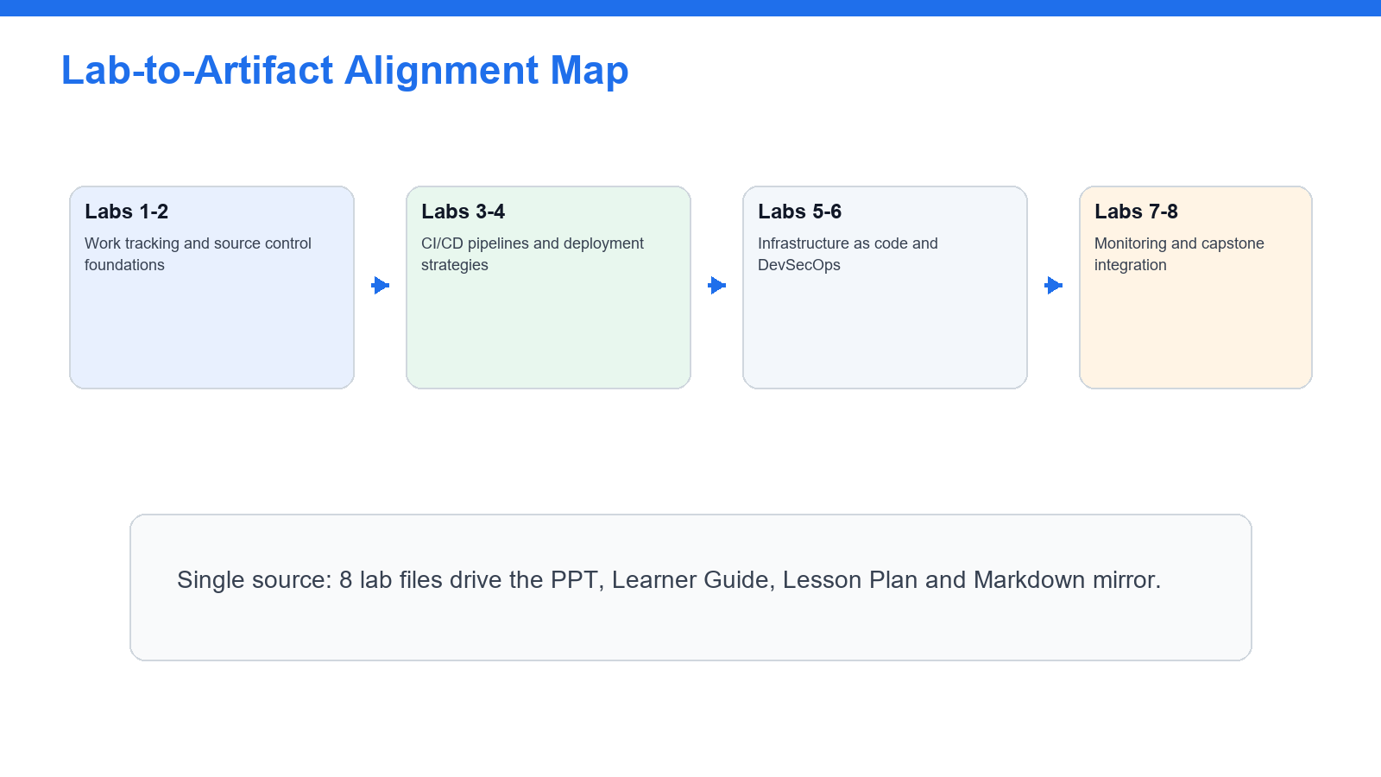
Each lab produces evidence that is reused in the Learner Guide, slide deck and Lesson Plan.

Visual Lab Roadmap
Lab | Focus | Build / Configure | Evidence
01 | DevOps Processes, Boards, and Traceability | Boards → Branch → Commit → Pull Request → Dashboard | Work items follow a clear hierarchy.
02 | Source Control, Branching, and Pull Requests | Repository → Branch → Pull Request → Review | Branch strategy fits the team scenario.
03 | YAML CI Pipelines, Testing, and Artifacts | YAML Pipeline → Build → Test → Artifact | Pipeline triggers correctly.
04 | Release Pipelines and Deployment Strategies | Artifact → Environment → Approval → Deployment | Deployment strategy matches risk and downtime needs.
05 | Infrastructure as Code with Bicep and Templates | Bicep Template → Validation → Deployment | Template is parameterized.
06 | DevSecOps, Secrets, and Compliance Scanning | Secrets → Scanning → Compliance Gate | No secrets are stored in code.
07 | Instrumentation, Monitoring, KQL, and Feedback | Telemetry → KQL → Dashboard → Feedback | Metrics connect to operational decisions.
08 | AZ-400 Capstone: End-to-End DevOps Solution | Plan → Code → Build → Release → Monitor | Solution includes traceability.

Lab Rules
- Do not commit real secrets.
- Use sandbox subscriptions where possible.
- Record pipeline run links or screenshots.
- Delete billable resources after labs.
- Document design tradeoffs, not only commands.

Lab 01 - DevOps Processes, Boards, and Traceability
Source Lab | courseware/labs-source/lab-01-devops-processes-boards-traceability.md

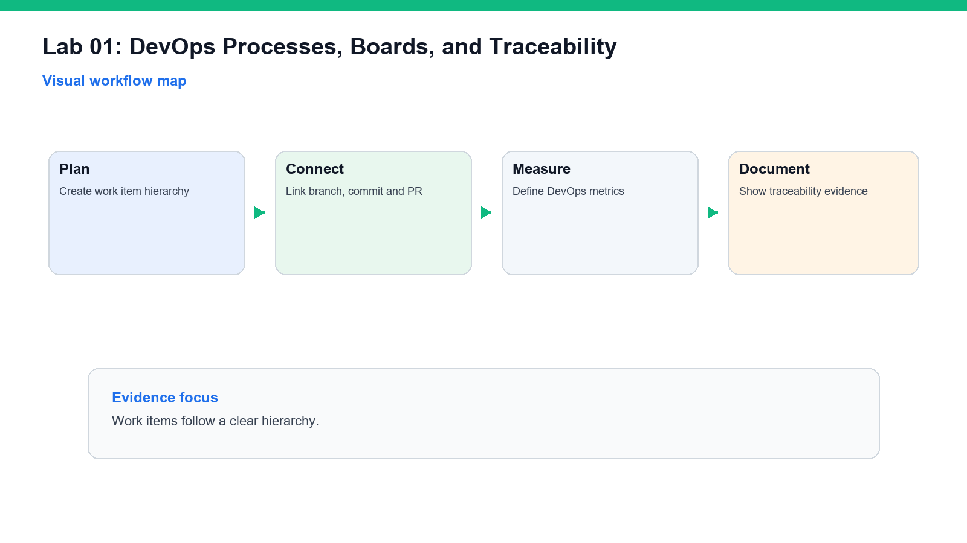
Visual workflow map for Lab 01.
What you will produce: Boards → Branch → Commit → Pull Request → Dashboard. Keep screenshots, links or generated artifacts as evidence.

Objectives
- Create a work tracking structure.
- Link work to code and releases.
- Define DevOps metrics.
- Create project documentation.

Step-by-Step Guide
- Create or open an Azure DevOps project or GitHub repository.
- Create sample epics, features, user stories, tasks, and bugs.
- Define workflow states.
- Add labels for priority, security, quality, and release.
- Link a work item to a branch, commit, and pull request.
- Create a dashboard or metric table.
- Define lead time, cycle time, deployment frequency, change failure rate, and MTTR.
- Create Markdown documentation.
- Add a Mermaid flow diagram.
- Document traceability from requirement to deployment.

Validation
- Work items follow a clear hierarchy.
- Traceability includes work, code, pipeline, and release evidence.
- Metrics are defined.
- Documentation is readable.
Evidence checkpoint: Work items follow a clear hierarchy.

Review Questions
- Why does traceability matter?
- What is the difference between lead time and cycle time?
- How can dashboards improve feedback?
- Why document architecture and releases?

Learner Evidence
- Screenshot or link to the completed work item, branch, pull request, pipeline run, deployment, dashboard or capstone evidence as relevant.

Lab 02 - Source Control, Branching, and Pull Requests
Source Lab | courseware/labs-source/lab-02-source-control-branching-pull-requests.md

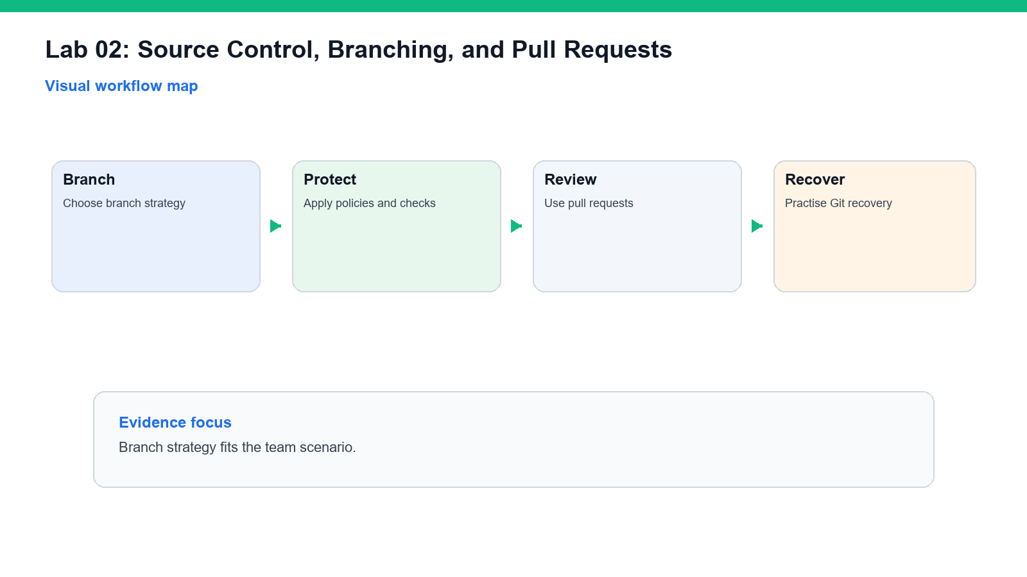
Visual workflow map for Lab 02.
What you will produce: Repository → Branch → Pull Request → Review. Keep screenshots, links or generated artifacts as evidence.

Objectives
- Choose a branch strategy.
- Configure pull request workflow.
- Apply branch protection or policies.
- Practise Git recovery.

Step-by-Step Guide
- Create or open a Git repository.
- Compare trunk-based, feature branch, and release branch strategies.
- Choose a branch strategy and document why.
- Create a feature branch.
- Make a small change.
- Commit and push the branch.
- Open a pull request.
- Require review and status checks where available.
- Add a release tag.
- Recover a previous file version with Git.
- Document how sensitive data removal should be escalated.

Validation
- Branch strategy fits the team scenario.
- Pull request includes review and checks.
- Tagging convention is documented.
- Git recovery step is successful.
Evidence checkpoint: Branch strategy fits the team scenario.

Review Questions
- When is trunk-based development useful?
- Why protect main?
- What is the purpose of release tags?
- Why is secret removal from Git history sensitive?

Learner Evidence
- Screenshot or link to the completed work item, branch, pull request, pipeline run, deployment, dashboard or capstone evidence as relevant.

Lab 03 - YAML CI Pipelines, Testing, and Artifacts
Source Lab | courseware/labs-source/lab-03-yaml-ci-pipelines-testing-artifacts.md

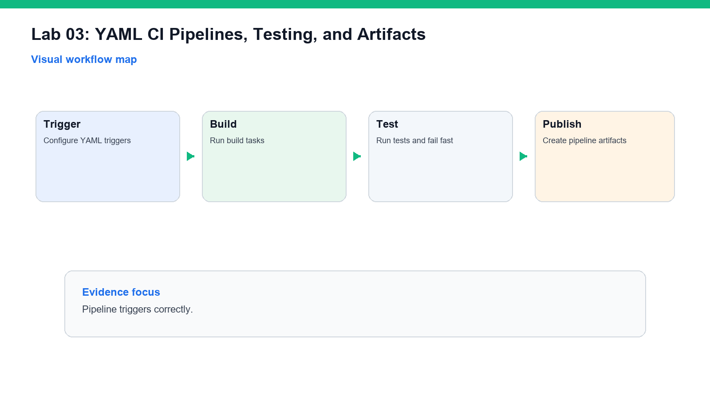
Visual workflow map for Lab 03.
What you will produce: YAML Pipeline → Build → Test → Artifact. Keep screenshots, links or generated artifacts as evidence.

Objectives
- Create a YAML CI pipeline.
- Configure triggers.
- Run tests.
- Publish artifacts.

Step-by-Step Guide
- Use a sample application repository.
- Add a YAML pipeline file.
- Configure triggers for main and pull requests.
- Add build steps.
- Add a unit test step.
- Publish test results where supported.
- Publish a build artifact.
- Use variables or reusable steps.
- Run the pipeline.
- Inspect logs.
- Fix one controlled failure.
- Record duration and improvement ideas.

Validation
- Pipeline triggers correctly.
- Tests run.
- Artifact is published.
- Failure is documented and fixed.
Evidence checkpoint: Pipeline triggers correctly.

Review Questions
- Why define pipelines as YAML?
- What should happen on pull request builds?
- Why publish artifacts?
- What makes a test flaky?

Learner Evidence
- Screenshot or link to the completed work item, branch, pull request, pipeline run, deployment, dashboard or capstone evidence as relevant.

Lab 04 - Release Pipelines and Deployment Strategies
Source Lab | courseware/labs-source/lab-04-release-pipelines-deployment-strategies.md

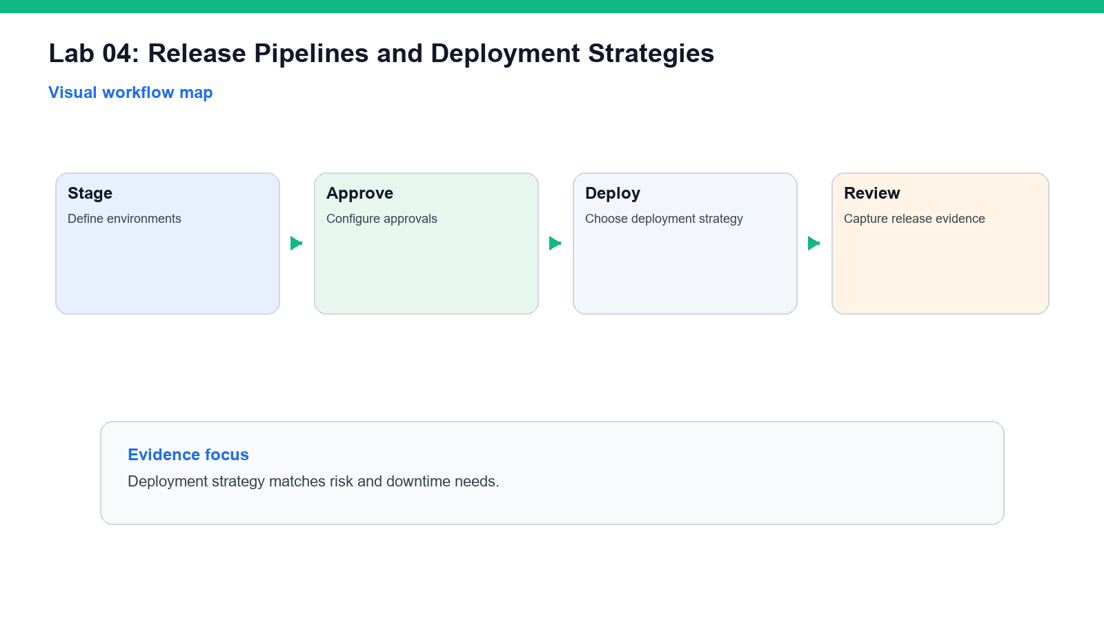
Visual workflow map for Lab 04.
What you will produce: Artifact → Environment → Approval → Deployment. Keep screenshots, links or generated artifacts as evidence.

Objectives
- Design release stages.
- Configure environments and approvals.
- Compare deployment strategies.
- Plan rollback and hotfix paths.

Step-by-Step Guide
- Define dev, test, staging, and production environments.
- Add deployment stages to a pipeline.
- Configure approvals or checks for higher environments.
- Compare blue-green, canary, ring, rolling, feature flags, and deployment slots.
- Choose a strategy for a sample app.
- Deploy a sample artifact or simulate deployment.
- Define rollback criteria.
- Define rollback steps.
- Define a hotfix path.
- Create release notes from commits or PRs.

Validation
- Deployment strategy matches risk and downtime needs.
- Approval/check evidence is captured.
- Rollback path is clear.
- Release notes are generated or drafted.
Evidence checkpoint: Deployment strategy matches risk and downtime needs.

Review Questions
- When would you use canary deployment?
- Why are approvals useful?
- What should a rollback plan include?
- How do feature flags reduce deployment risk?

Learner Evidence
- Screenshot or link to the completed work item, branch, pull request, pipeline run, deployment, dashboard or capstone evidence as relevant.

Lab 05 - Infrastructure as Code with Bicep and Templates
Source Lab | courseware/labs-source/lab-05-infrastructure-as-code-bicep-templates.md

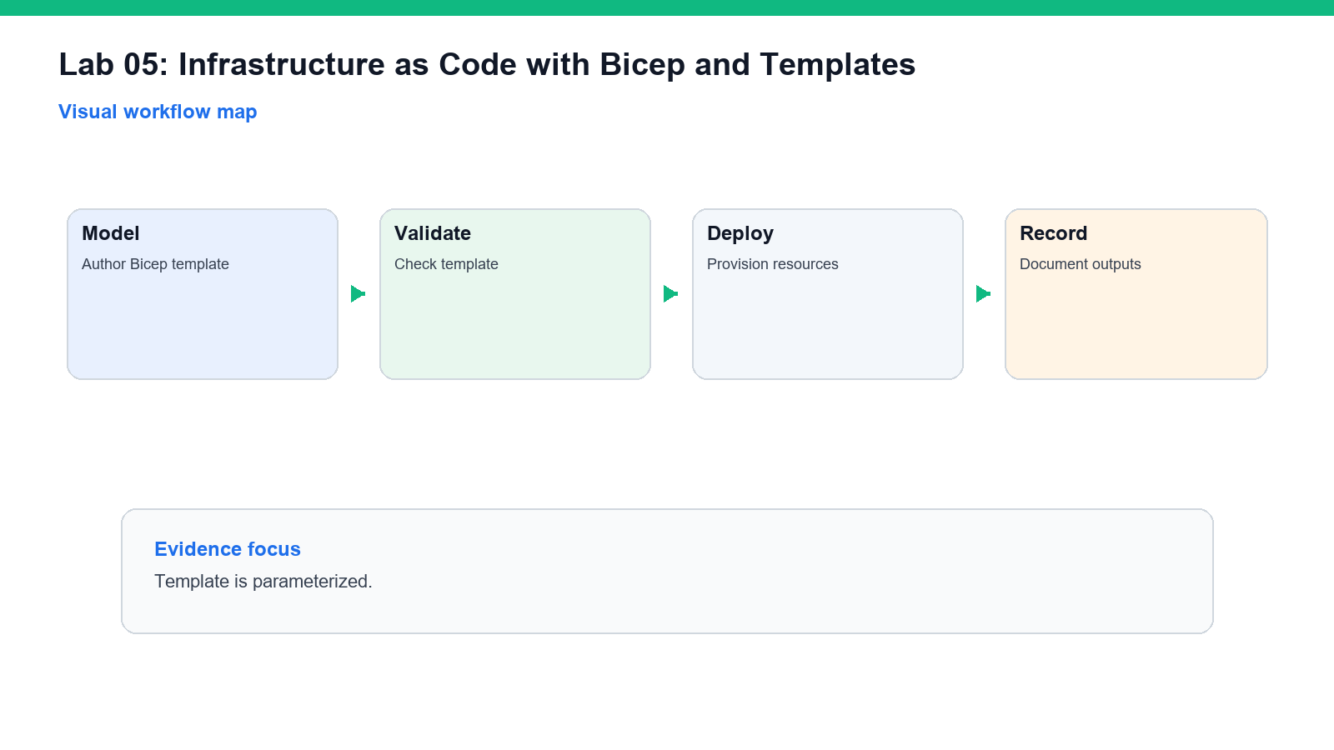
Visual workflow map for Lab 05.
What you will produce: Bicep Template → Validation → Deployment. Keep screenshots, links or generated artifacts as evidence.

Objectives
- Define IaC strategy.
- Create a Bicep or template file.
- Validate deployment.
- Document review and drift controls.

Step-by-Step Guide
- Identify infrastructure required by the sample app.
- Create or review a Bicep template.
- Add parameters for environment and location.
- Add resource tags.
- Validate the template.
- Deploy to a sandbox or review simulated deployment output.
- Store the template in source control.
- Add an IaC step to a pipeline.
- Document how drift can occur.
- Define review and approval rules for IaC changes.

Validation
- Template is parameterized.
- Tags are included.
- Validation or deployment evidence is captured.
- Drift and review controls are documented.
Evidence checkpoint: Template is parameterized.

Review Questions
- Why use IaC?
- What should be parameterized?
- What is configuration drift?
- Why should infrastructure changes use pull requests?

Learner Evidence
- Screenshot or link to the completed work item, branch, pull request, pipeline run, deployment, dashboard or capstone evidence as relevant.

Lab 06 - DevSecOps, Secrets, and Compliance Scanning
Source Lab | courseware/labs-source/lab-06-devsecops-secrets-compliance-scanning.md

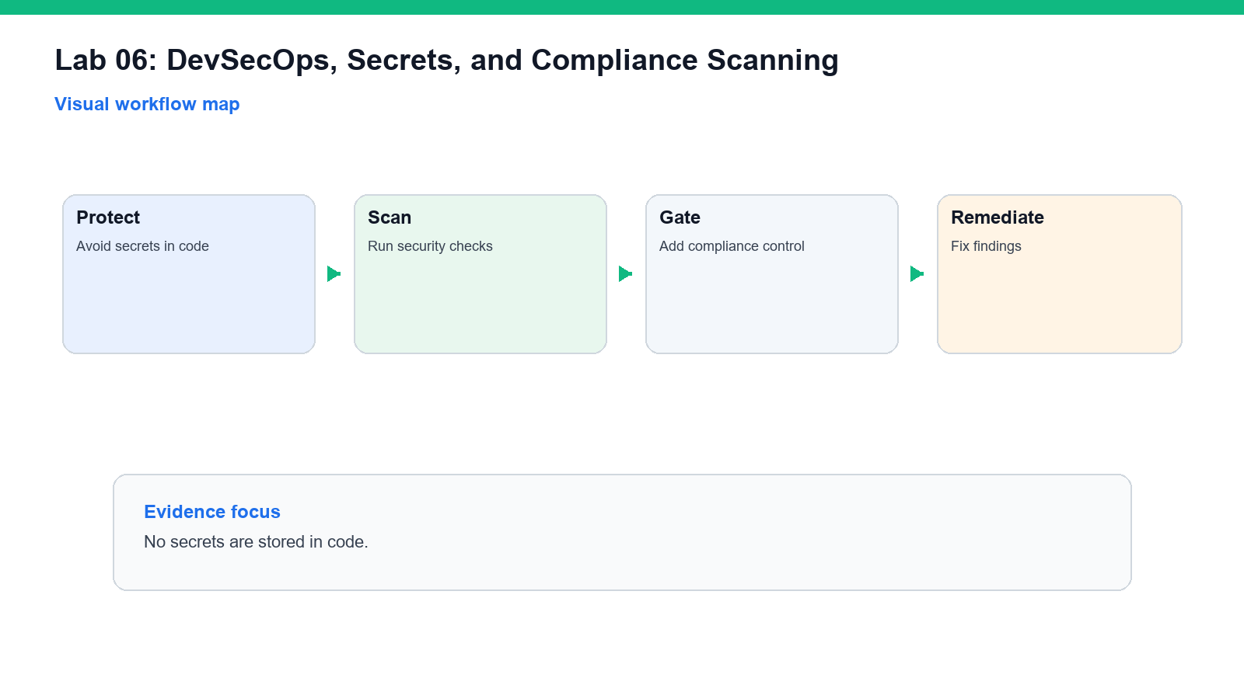
Visual workflow map for Lab 06.
What you will produce: Secrets → Scanning → Compliance Gate. Keep screenshots, links or generated artifacts as evidence.

Objectives
- Manage secrets safely.
- Design secure pipeline authentication.
- Configure scanning checks.
- Document compliance evidence.

Step-by-Step Guide
- Identify secrets used by the sample app or pipeline.
- Move secrets to GitHub secrets, Azure Pipelines variables, or Key Vault.
- Compare service principals, managed identities, and OIDC.
- Review service connections or GitHub Actions authentication.
- Enable dependency scanning where available.
- Enable secret scanning or add a secret scanning step.
- Add CodeQL or static analysis conceptually or practically.
- Review container scanning concepts.
- Define a policy for critical findings.
- Create a compliance evidence table.

Validation
- No secrets are stored in code.
- Authentication design follows least privilege.
- Scanning plan covers code, dependencies, secrets, and containers.
- Evidence table is audit-friendly.
Evidence checkpoint: No secrets are stored in code.

Review Questions
- Why avoid long-lived secrets?
- What is OIDC workload identity federation?
- Why scan dependencies?
- What should block a release?

Learner Evidence
- Screenshot or link to the completed work item, branch, pull request, pipeline run, deployment, dashboard or capstone evidence as relevant.

Lab 07 - Instrumentation, Monitoring, KQL, and Feedback
Source Lab | courseware/labs-source/lab-07-instrumentation-monitoring-kql-feedback.md

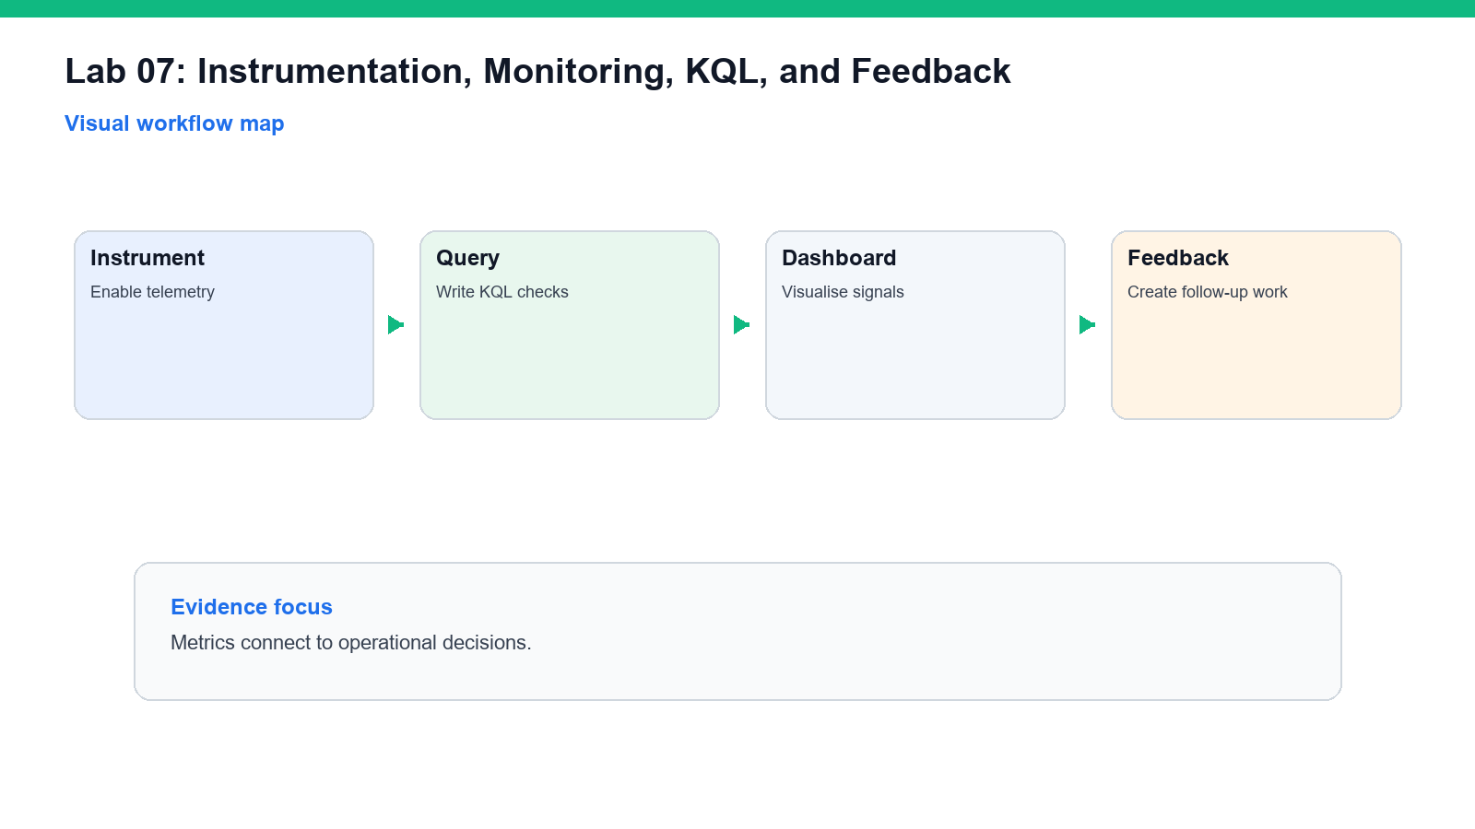
Visual workflow map for Lab 07.
What you will produce: Telemetry → KQL → Dashboard → Feedback. Keep screenshots, links or generated artifacts as evidence.

Objectives
- Design monitoring strategy.
- Review Azure Monitor and Application Insights.
- Write KQL queries.
- Create feedback loops.

Step-by-Step Guide
- Identify telemetry required for the sample application.
- Define application, infrastructure, pipeline, security, and operations metrics.
- Review Application Insights concepts.
- Review Azure Monitor Logs concepts.
- Create or design alert rules.
- Review pipeline run history and failure rate.
- Write simple KQL queries.
- Identify distributed tracing concepts.
- Define notifications to Teams, GitHub Issues, or Azure Boards.
- Write an instrumentation strategy note.

Validation
- Metrics connect to operational decisions.
- Alerts have clear action.
- KQL queries are documented.
- Feedback loop is practical.
Evidence checkpoint: Metrics connect to operational decisions.

Review Questions
- What is MTTR?
- Why collect pipeline metrics?
- What is KQL used for?
- How does feedback improve delivery?

Learner Evidence
- Screenshot or link to the completed work item, branch, pull request, pipeline run, deployment, dashboard or capstone evidence as relevant.

Lab 08 - AZ-400 Capstone: End-to-End DevOps Solution
Source Lab | courseware/labs-source/lab-08-capstone-az400-end-to-end-devops.md

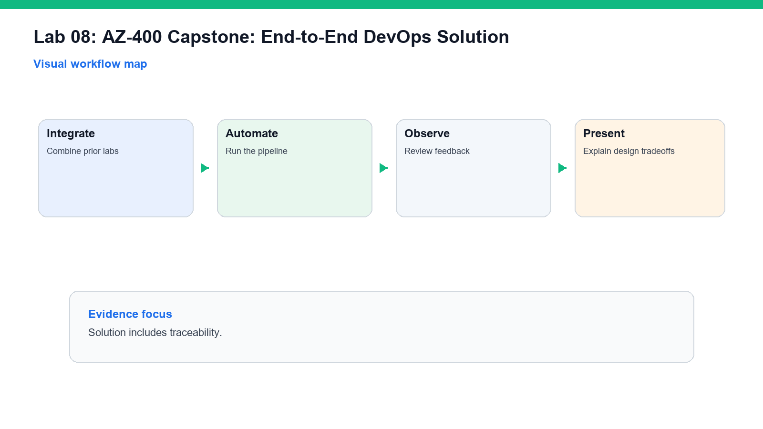
Visual workflow map for Lab 08.
What you will produce: Plan → Code → Build → Release → Monitor. Keep screenshots, links or generated artifacts as evidence.

Objectives
- Design a complete DevOps solution.
- Combine work tracking, source control, pipelines, security, and monitoring.
- Make tradeoff decisions.
- Build an exam study plan.

Step-by-Step Guide
- Review the trainer-provided scenario.
- Design flow of work using Boards or Issues.
- Choose a branching and PR strategy.
- Design CI pipeline stages.
- Design deployment strategy and environment gates.
- Add IaC and configuration management.
- Add secrets, security scanning, and compliance evidence.
- Add monitoring, alerts, and KQL.
- Identify risks and mitigations.
- Create an executive summary.
- Create technical design notes.
- Map weak areas to AZ-400 domains.
- Write a 14-day study plan.

Validation
- Solution includes traceability.
- Pipeline strategy covers build, test, release, and rollback.
- Security and monitoring are built in.
- Study plan targets weak domains.
Evidence checkpoint: Solution includes traceability.

Review Questions
- Which design tradeoff was hardest?
- How does the solution improve deployment confidence?
- What evidence would an auditor need?
- Which AZ-400 domain needs more review?

Learner Evidence
- Screenshot or link to the completed work item, branch, pull request, pipeline run, deployment, dashboard or capstone evidence as relevant.

Troubleshooting
- Confirm the correct organization, project, repository, branch and service connection are selected.
- Check permissions before creating pipelines, service connections, policies or Azure resources.
- Re-run failed pipelines after reading the first failing task log.
- Never paste secrets into Markdown, pipeline YAML, issue comments or screenshots.

